**DEPLOY GUIDE WEB ADMIN**



**MOBILE WORKING REPORT**

**FUJITSU INDONESIA**

# Tools instalation

* Apache
* Mysql
* Text Editor (Sublime Text)

# Issue

Check all privileges in database mysql

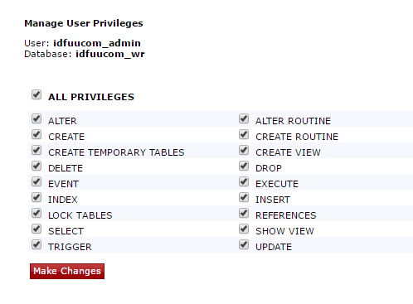

# Configure web admin

## Set up connection to database

Go to file **FID-WR\admin-wr\php\config.php**

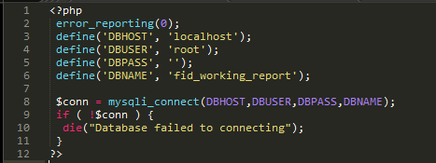

* DBHOST : Host of database
* DBUSER : User of database
* DBPASS : Password of database
* DBNAME : Database name

## Login page

File PHP :

* **Login.php**
* **Php/auth.php**

### Check Login_id and Password

To check login_id and password go to **php/auth.php**

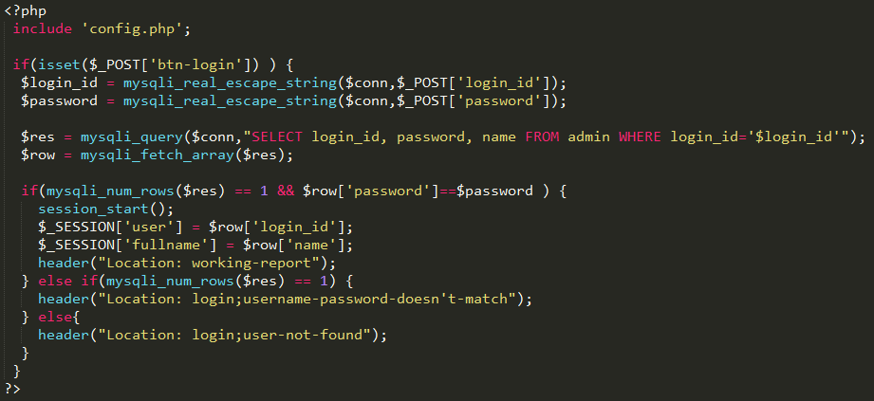

Checking login_id and password from database in file **php/auth.php**

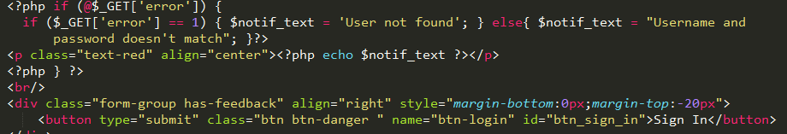

Then the system go to login.php and check error output from php/auth.php if error is true it will show a pop up.

## Sidebar

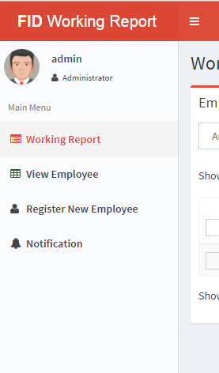

File PHP :

* Working-report.php
* View-employee.php
* Register-employee.php
* Notification.php

In every function, there is a sidebar code, So if you want to change or edit, you have to change in every function file.

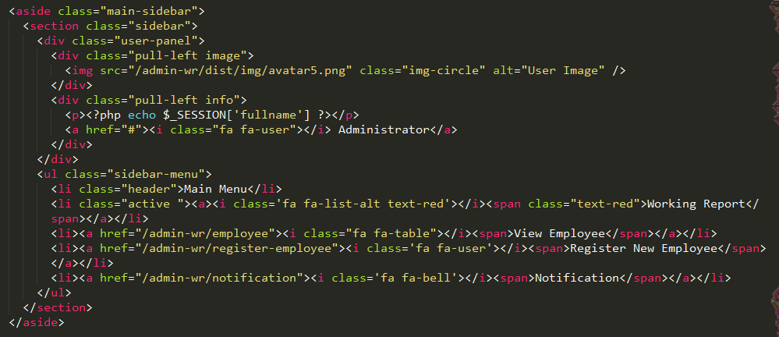

## Working Report

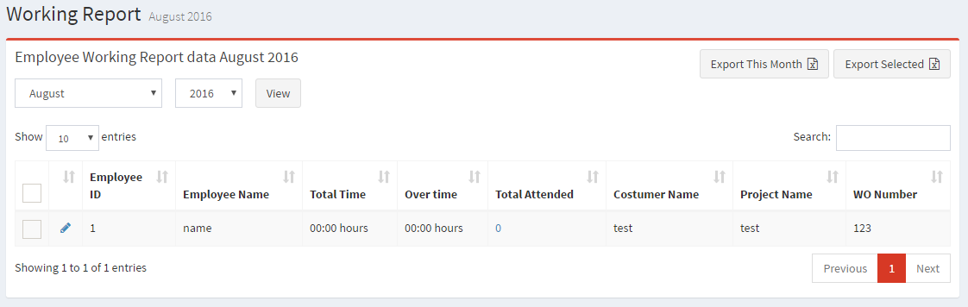

In working report menu there are several function, such as export general, export selected, view working report employee in selected month and year and detail working report.

File PHP :

* Working-report.php
* Php/wr-page.php

### Export General and Export Selected



File PHP : **Working-report.php**

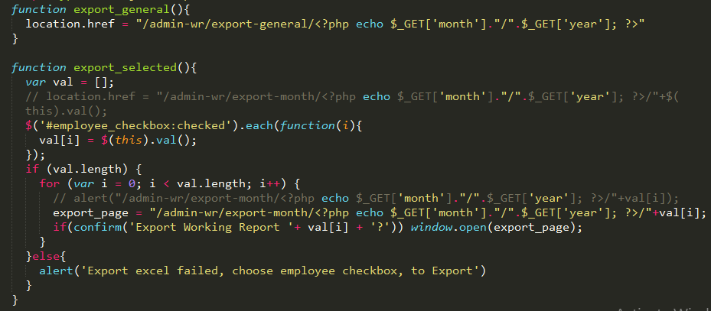

For export general, system only GET month and year to export, while export selected system had to check the check box then check the month and year from the selected row. If there are not box checked, system give an alert.

### Working Report General

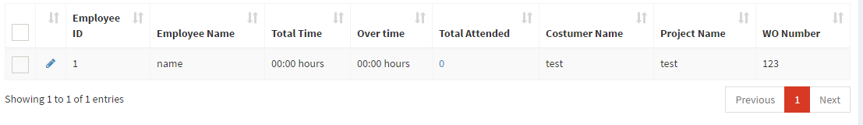

File php : **Working-report.php**



This query for presenting data from two database from month_attended and employee.

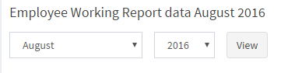

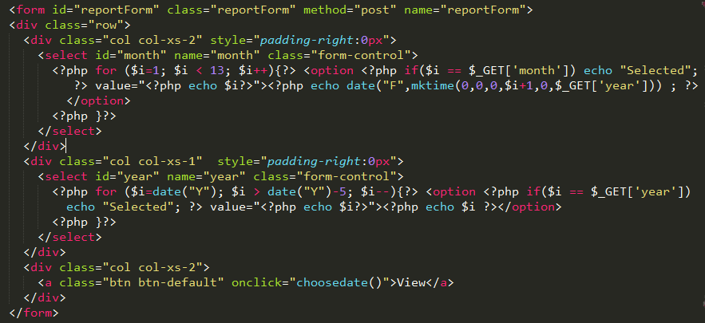

To presenting data working report, we have to select month and year.

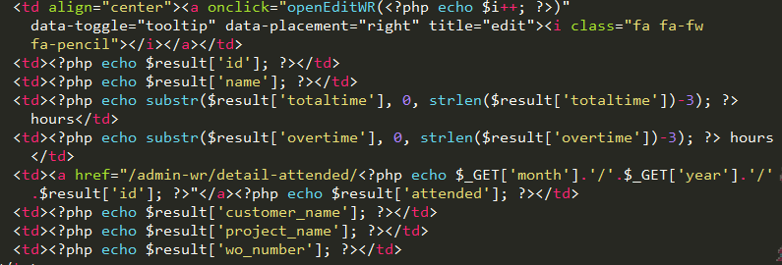

This one is the code for presenting data general working report of employee from selected month and year.

### Working Report Detail

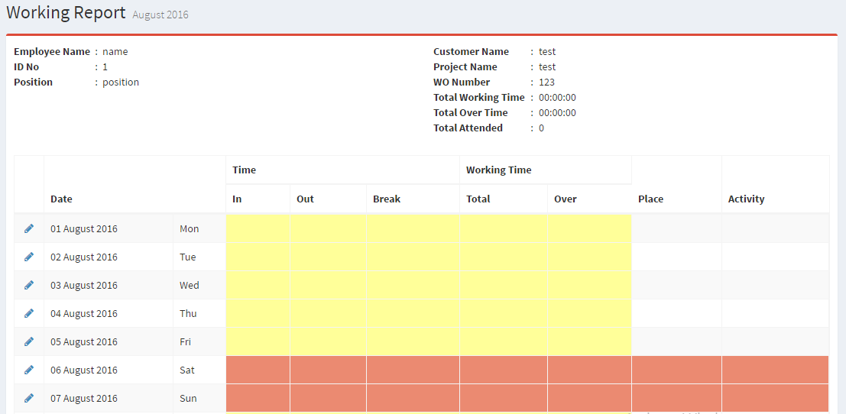

File PHP : **detail-attend.php**

Initialization from variable

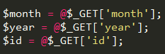

### Employee Information

File php : **deail-atend.php**

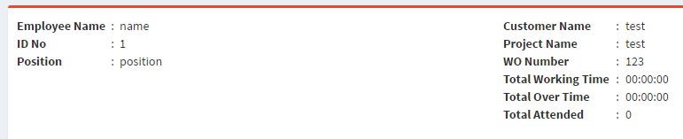

This is contain some informations from employee and the project. We get this informations from month_attended and employee table in database

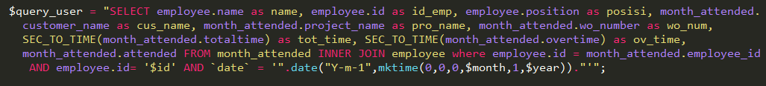

We select the data which we will present from two tables then we filter the information according to employee id and date.

### Employee Attendance

File php : **detail-attend.php**

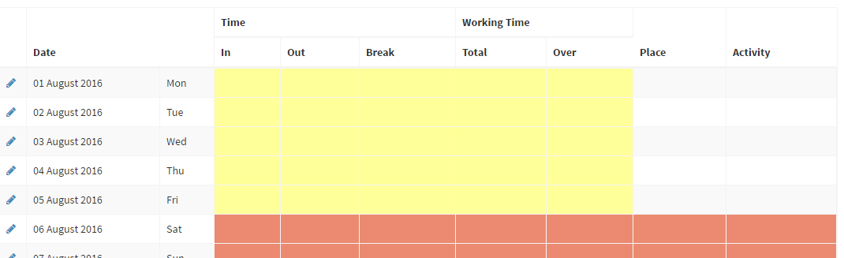



To get the data from employee and attendance.

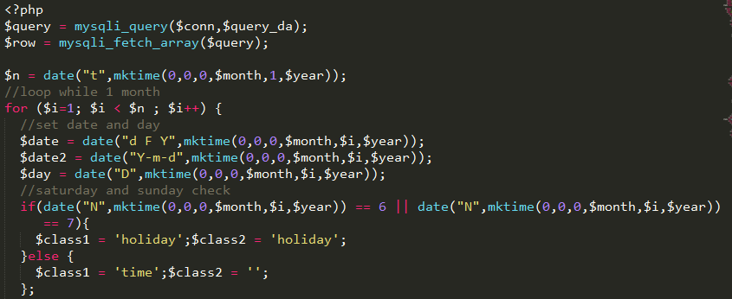

Looping data for 1 month, then set date and day and checking the data in Saturday or Sunday.

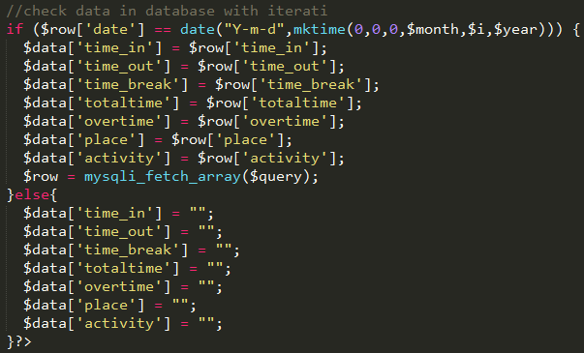

This is for iteration database.

## View Employee

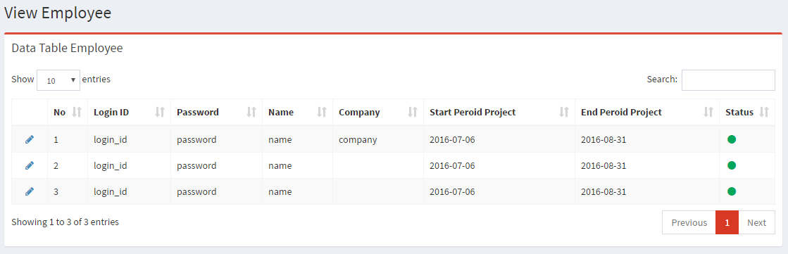

File PHP : **view-employee.php**

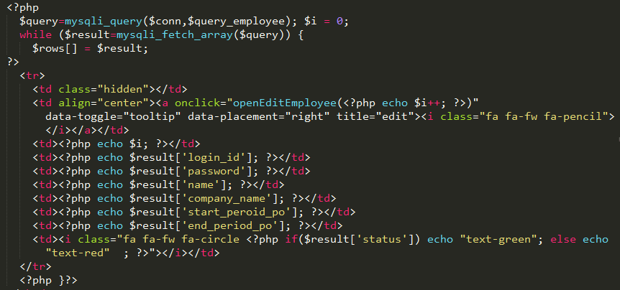

Select all data from table employee, then we can choose some data which we will use.

### Edit Employee

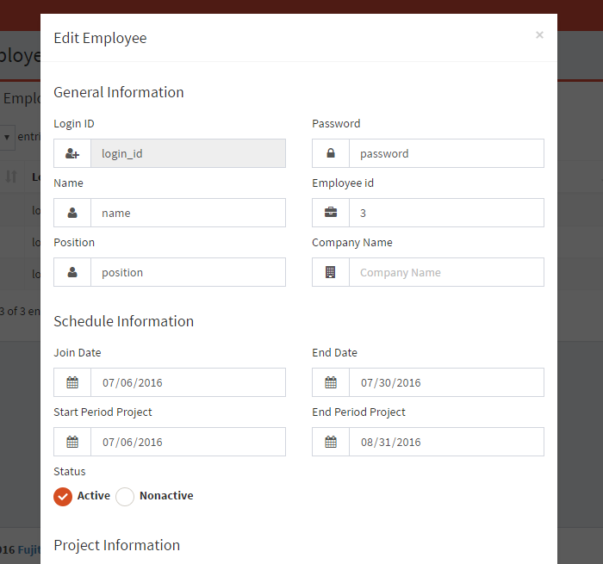

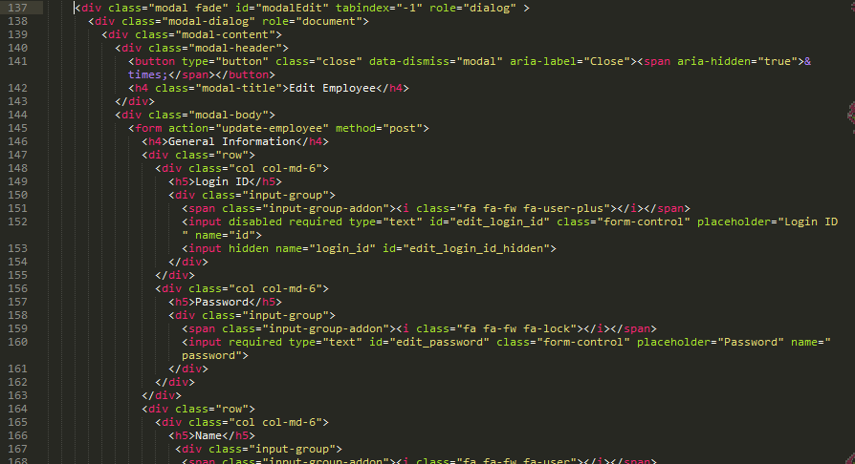To open modal edit, open file **view-employee.php**

From line 137 until 305 is code to show modal of update employee form

## Register New Employee

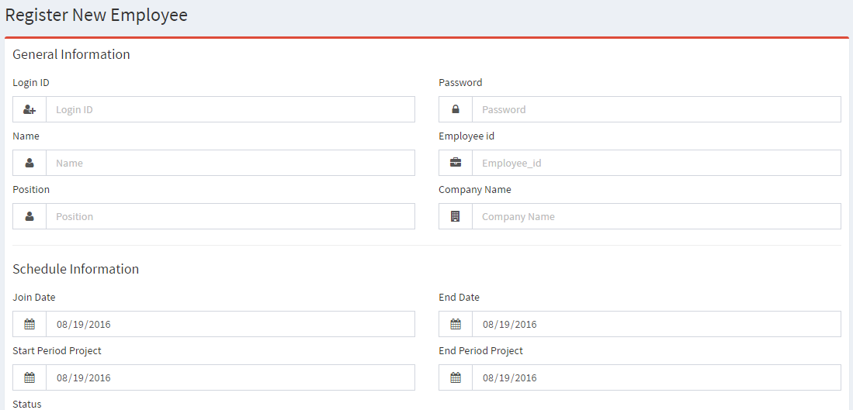

File PHP : **register-employee.php**

## Notification

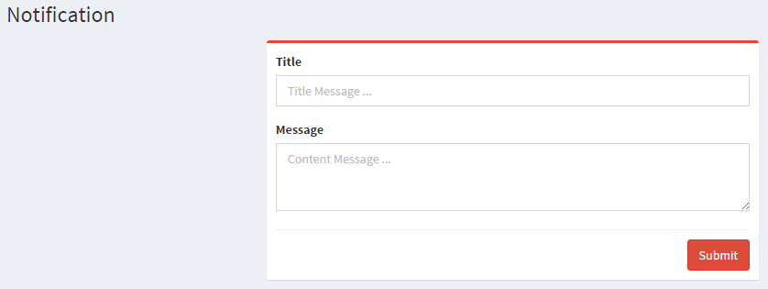

File PHP : **Notification.php**

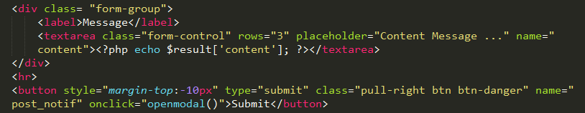

Backend to push notification in **php\notif.php**

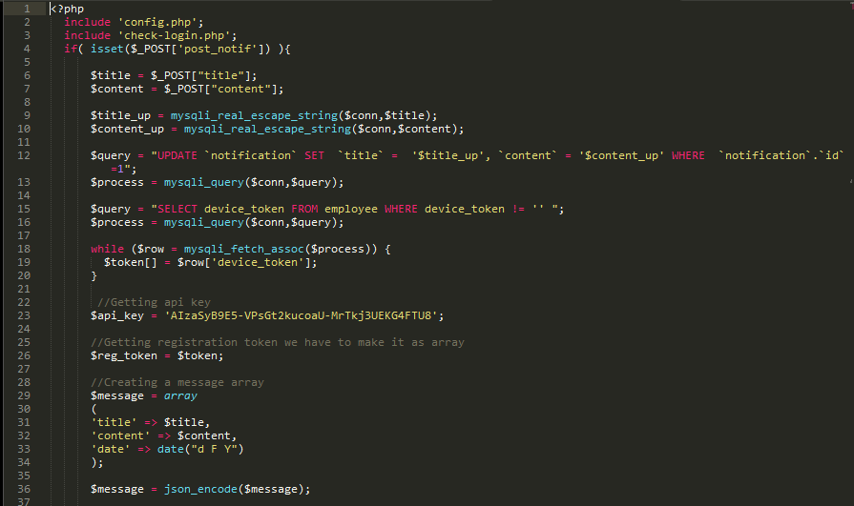

Line 12 is the query to save last notification push.

Line 15 is the query to get device token from employee table in database.

Line 23 is api key from GCM (Google Cloud Messsaging)

Line 29 until 34 is message that push into apps. The message encoded into json then the system push it by GCM.